**Project Design Phase-II**

**Data Flow Diagram & User Stories**

|  |  |
| --- | --- |
| **Date** | **26 October 2022** |
| **Team ID** | **PNT2022TMID15139** |
| **Project Name** | **Smart Farmer-IOT Enabled Smart Farming Application** |
| **Maximum marks** | **4 Marks** |

**Data Flow Diagrams:**

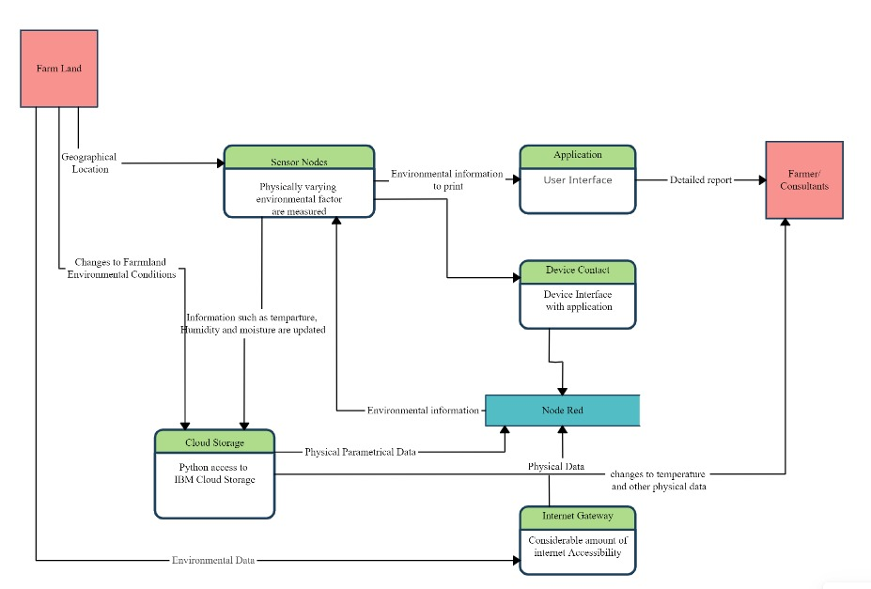

1. The different soil parameters temperature, soil moistures and then humidity are sensed using different sensors and obtained value is stored in the Ibm cloud.
2. Arduino UNO is used as a processing Unit that process the data obtained from the sensors and whether data from the weather API.
3. NODE-RED is used as a programming tool to write the hardware, software and APIs. The MQTT protocol is followed for the communication.
4. All the collected data are provided to the user through a mobile application that was developed using the MIT app inventor. The user could make a decision through an app, weather to water the crop or not depending upon the sensor values. By using the app they can remotely operate to the motor switch.

**User Stories**

Use the below template to list all the user stories for the product.

|  |  |  |  |  |  |  |
| --- | --- | --- | --- | --- | --- | --- |
| **User type** | **Functional Requirement (Epic)** | **User Story Number** | **User Story / Task** | **Acceptance criteria** | **Priority** | **Release** |
| Customer (Mobile user) | Registration | USN-1 | As a user, I can register for the application by entering my email, password, and confirming my password. | I can access my account / dashboard | High | Sprint-1 |
| Customer (Web user) | Dashboard | USN-2 | As a user, I will receive confirmation email once I have registered for the application | I can receive confirmation email & click confirm | High | Sprint-1 |
|  | Registration | USN-3 | As a user, I can register for the application through Facebook |  | Low | Sprint-2 |
|  |  | USN-4 | As a user, I can register for the application through Gmail |  | Medium | Sprint-1 |
|  | Login | USN-5 | As a user, I can log into the application by entering email & password |  | High | Sprint-1 |
|  | Dashboard |  |  |  |  |  |
| Customer (Web user) |  |  |  |  |  |  |
| Customer Care Executive | Help | USN-1 | As a user, if I have any queries or issues , I can reach out to the Support team | I will receive a reply from the support team that my message is accepted and later my queries or issues will be resolved | Medium | Sprint-3 |
| Administrator | Management | USN-1 | As a user, I need the resource management team to use quality products at the reasonable price | I get a warranty card and details about the product | Medium | Sprint-4 |
|  |  | USN-2 | As a user, if I didn’t receive a quality product,I want a refund. | I can receive a free service or a change of product | Medium | Sprint-4 |